Eliezer Ben-Yehuda
January 7,1858-December 16,1922

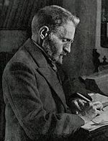
Eliezer Ben-Yehuda, originally Eliezer Yitzhak Perelman, was born in Lithuania. From an early age he was exposed to the Hebrew of the Torah, Talmud, and Mishnah at home and at school. He studied in a yeshiva and his parents hoped he would become a rabbi. However, Ben Yehuda began studying other languages and secular texts. Eventually he moved away from the yeshiva and attended a university in Paris, studying history, politics, and Hebrew. His Hebrew studies had the largest impact on him and he became more involved in Zionism as well.

During Ben-Yehuda's time, only 150 years ago, there was no common language to unite the Jewish people. Hebrew was used almost exclusively in the synagogue. People could use the religious language if they had to, but Ben-Yehuda set about making it the common language and uniting force of the Jewish people.

Eliezer Ben-Yehuda made aliyah to Jerusalem in 1881 and taught at the Alliance Israelite Universelle school. The land then was largely populated by Arabs and it was under Ottoman
rule.

Ben-Yehuda was only 23 at the time and was determined to make every moment count in establishing Hebrew as the common language for the Jews, replacing Yiddish as the main means of communication between Jewish people from separate areas. He conducted a unique experiment and his own son, Itamar, was the guinea pig. He refused to allow his little boy to hear any language other than Hebrew. When visitors came, Itamar was banished to his bedroom to prevent him from hearing a language other than Hebrew. In this way, Ben-Yehuda turned his son into the first Hebrew speaking child in modern history.

Ben Yehuda passed away in 1922 of tuberculosis. 30,000 people attended his funeral on the Mount of Olives in Jerusalem.

Theodor Herzl
May 2, 1860- July 3, 1904

Theodor Herzl, originally Benjamin Ze’ev Herzl, was born in Budapest in 1860. His family was mainly secular, largely influenced by the German Jewish Enlightenment of the period. Before becoming known as the “father of modern Zionism,” Herzl attended the University of Vienna and became a writer and journalist.
In 1894, when Herzl was working as a correspondent for the Neue Freie Presse in Paris, he followed the events of the Dreyfus affair. During this time, Captain Alfred Dreyfus, a Jewish officer in the French army, was unjustly accused of spying for Germany and Herzl witnessed mobs shouting “Death to the Jews” on the streets of France. Despite the fact that Herzl was an assimilated Jew, this outright antisemitism led him to believe that the only solution to the Jewish problem was mass immigration and the creation of a Jewish state.
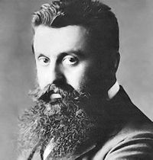
Two years later, in 1896, Herzl published Der Judenstaat (The Jewish State), explaining that antisemitism will not be solved, but can be avoided by establishing a separate state for the Jewish people. Herzl spread his message to wealthy donors and to the masses, resulting in the First Zionist Congress in Basle, Switzerland, on August 29­31, 1897.
During this conference, Herzl founded the Zionist Organization (later renamed the World Zionist Organization) and became its first president. The delegates also established at the Basle Program, which declared, “Zionism seeks to establish a home for the Jewish people in Palestine, secured under public law.”
After the First Zionist Congress, the movement met yearly and in 1936, the center of the Zionist transferred to Jerusalem.
At the last Zionist conference that Herzl convened, in 1903, he proposed the British Uganda Program as a temporary refuge for Jews in Russia in immediate danger. Herzl made it clear that this program would not affect the ultimate aim of Zionism, a Jewish entity in the Land of Israel, but the proposal received a lot of pushback and almost led to a division in the Zionist movement. Delegates at the Seventh Zionist Congress in 1905 rejected the Uganda Program.
Herzl died in Vienna in 1904 of pneumonia at the age 44. By then the movement had found its place on the world political map. In 1949, Herzl’s remains were brought to Israel and placed on Mount Herzl in Jerusalem.

Golda Meir
May 3, 1898- December 8, 1978

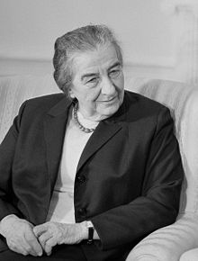
Golda Meir (born Golda Mabovich) was born in Kiev in 1898 and her family immigrated to Milwaukee, Wisconsin in 1906. She was a natural leader as a teenager and became involved in the Zionist youth group, Poalei Zion (Workers of Zion; now known as Habonim Dror). The nicknames Meir achieved through the years reflect her leadership abilities. She was often seen as the “Iron Lady” of Israeli politics or as Ben Gurion claimed, as “the best man in the government.”
Golda Meir’s dedication to Labor Zionism influenced her decision to immigrate to the British Mandate of Palestine in 1921, along with her husband, Morris Myerson. The couple lived on a kibbutz for three years before moving to Jerusalem.
Meir worked for several different organizations, including the Working Women’s Council and the Histadrut Trade Union, before working her way up into higher government positions. She became the head of the Jewish Agency’s Political Department in 1946. In 1948, when there were doubts that the American Jewish community would financially support Israel, Meir traveled to the United States and raised $50 million. The money went towards purchasing supplies that would be used during the Israeli War of Independence. Later that year, Meir became one of two women who signed Israel’s Declaration of Independence. She was also appointed as Israel’s Ambassador to the Soviet Union and continued creating bridges between Israel and other countries throughout her career.
In 1969, at the age of 71, Meir returned from retirement to serve as Prime Minister, becoming the world’s third female Prime Minister (after Sirimavo Bandaranaike of Sri Lanka and Indira Gandhi of India).
During her years as Prime Minister, two major events occurred: First, the Munich massacre at the 1972 Summer Olympics, during which eleven members of the Israeli Olympics team were taken hostage and killed. Then, the Yom Kippur War from October 6-25,1973 when Egypt and Syrian jointly surprise attacked Israel.
Meir resigned as Prime Minister in 1974 and Yitzhak Rabin took the stage. She passed away in December 1978 and was buried on Mount Herzl in Jerusalem.

Yitzhak Rabin
March 1, 1922- November 4, 1995

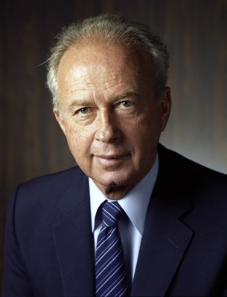
Yitzhak Rabin was born in 1922 in Jerusalem during the British Mandate of Palestine and grew up in Tel Aviv. His father, Nehemiah, was originally from Ukraine, but lived in the United States for several years. He immigrated to the British Mandate of Palestine in 1917 with the Jewish Legion, one of the volunteer units of the British Army. Rabin’s mother, Rosa, was from Belarus and worked on a kibbutz by the Galilee before residing in Jerusalem. She was an early member of the Jewish defense organization, the Haganah.
Rabin followed the path of his parents, becoming a soldier and later a Chief Operations Officer of the Palmach, the elite unit of the Haganah. During the War of Independence in 1948, Rabin directed Israeli operations in Jerusalem and fought the Egyptian army in the Negev. He also served as the chief of staff of the IDF during the Six Day War in 1967, during which Israel gained territory from Egypt, Syria, and Jordan, gaining access to the Old City in Jerusalem.
Rabin was the first Israeli born Prime Minister and served twice in the role, from 1974-1977 and 1992-1995. During both of his terms as Prime Minister, he attempted to solve problems between Israel and its neighbors. In 1975, Rabin signed the Sinai Interim Agreement between Israel and Egypt where both countries declared that the conflict between them should be resolved by peaceful means rather than military force. In 1976, Rabin ordered Operation Entebbe, an undercover raid that rescued passengers of an airliner hijacked by Palestinian militants, rescuing 102 hostages.
During his second term in office, Rabin played a leading role in the signing of the Oslo Accords, which granted the Palestinian National Authority partial control over parts of the Gaza Strip and West Bank. He won the Nobel Peace Price in 1994 with Yasser Arafat and Shimon Peres for their roles in the Oslo Accords and efforts to resolve the Israeli-Palestinian conflict.
On November 4, 1995, Rabin was assassinated in Tel Aviv at a peace rally. The man who committed the horrible crime was a radical Jewish man who opposed the signing of the Oslo Accords and did not believe in trading Israel’s land for peace. Rabin was buried on Mt. Herzl in Jerusalem, surrounded by influential leaders from Israel and the United States. The place where he was assassinated in Tel Aviv was renamed Rabin Square. Jews from around the world come to visit this memorial site, lighting candles and singings songs of peace.

